Art that feels personal
Paintings created around people, places, celebrations, and stories that matter to you.
I’m Shivani Jaiswal, a fine artist creating live wedding paintings, portraits, pet portraits, spiritual art, abstract pieces, and custom commissions.
[ Explore My Work ]
[ Enquire About a Painting ]

A Few Pieces From My World
Live weddings. Portraits. Pets. Spiritual art. Abstract work. Personal commissions.
Each one begins differently.
[ View the Gallery ]

What I Paint

Live Wedding Painting
Your wedding, painted as it unfolds.
I paint your chosen moment live at the venue with acrylics, completing the artwork during the celebration.
[ Explore Live Wedding Painting ]

Portraits
Personal portraits of couples, families, parents, and individuals, created from photographs and meaningful references.
[ View Portraits ]

Pet Portraits
Because pets may be small, but they become such a big part of the family.
I try to capture the little expressions and details that make your pet so special to you.
[ View Pet Portraits ]

Religious & Spiritual Art
Paintings inspired by faith, tradition, and devotion, from deities and sacred scenes to artwork created especially for your home or as a meaningful gift.
[ Explore Spiritual Art ]

Abstract Art
Original pieces shaped by colour, movement, texture, and feeling.
Created for people who connect with art without needing it to tell a literal story.
[ Explore Abstract Art ]

Custom Artwork
Have something else in mind?
A home. A place. A photograph. A memory. A gift. An idea.
Tell me about it, and we can create something around your story.
[ Discuss a Custom Piece ]

Made to Mean Something
I have always believed that a painting should feel personal.
Sometimes it starts with a wedding. Other times, it could be a photograph of someone you love, your pet, a special place, or simply an idea you have had for some time..
Whatever the idea is, I create every painting with the person and story behind it in mind.

Hello, I’m Shivani
I have loved drawing and painting for as long as I can remember.
I hold a BFA and MFA in Fine Arts and have been working as an artist for more than 10 years.
I am also currently undertaking advanced academic art training through an Atelier programme.
Over the years, I have worked on everything from studio paintings and portraits to pet art, spiritual pieces, abstract work, and live weddings.
The subjects change, but what I look for stays the same, something that makes the painting feel like it belongs to the person it was created for.
BFA & MFA in Fine Arts · 10+ Years of Experience · Advanced Atelier Training · Original Hand-Painted Artwork
[ More About Shivani ]

Live Painting, While the Moment Is Still Happening
There is something very different about watching a blank canvas slowly become part of a celebration.
For live weddings, I arrive before the main moment, set up at the venue, and begin building the scene.
As the celebration unfolds, the people, colours, and details are added to the canvas.
By the end of the event, the painting is complete and ready for its reveal.
[ See How Live Wedding Painting Works ]

From an Idea to a Painting

1. Tell Me What You Have in Mind
Share your idea, reference photograph or, for a wedding, your date and venue.

2. We Plan the Piece
We decide the subject, size, composition, and the details that matter most to you.

3. I Begin Painting
Live wedding paintings are created in acrylic at the venue. Other commissions are created according to the agreed process and timeline.

4. Your Painting Is Ready
A finished, original piece created specifically for you.
[ Start a Commission ]

The Experience Behind the Canvas

Fine Art Training
BFA and MFA in Fine Arts, with more than ten years of professional painting experience.

Every Piece Is Personal
No templates. No two commissions begin with exactly the same story.

Experience With Live Events
Years of painting around real celebrations have taught me how to work within the energy of the event without becoming a distraction.

Original Artwork
Every canvas is individually painted and created as an original piece.

Kind Words
[Add genuine client testimonial here]
Client Name
Live Wedding Painting
[Add genuine client testimonial here]
Client Name
Portrait Commission
[ Read More Stories ]

From My Easel
Behind-the-scenes moments, works in progress, wedding paintings, studio commissions, and finished artwork.
[ Follow on Instagram ]

A Few Common Questions

What kind of artwork do you create?
I create live wedding paintings, portraits, pet portraits, religious and spiritual art, abstract pieces, and custom commissioned artwork.

Do you only paint weddings?
No. Live wedding painting is one part of my work. I also take personal commissions for portraits, pets, spiritual artwork, abstract pieces, and other custom ideas.

What medium do you use for live wedding paintings?
I use acrylic paint for live weddings because it allows me to work efficiently at the venue and complete the artwork during the event.

Is the wedding painting completed at the venue?
Yes. The painting is completed at the wedding venue and does not go through a separate studio-finishing stage afterwards.

Can you create a painting from a photograph?
Yes. Many portraits and custom commissions begin with photographs or other visual references.

Do you travel for weddings?
Yes. I travel for selected weddings across India and can also discuss destination and international enquiries depending on availability.
[ View All FAQs ]

Have Something in Mind?
It does not need to be fully figured out before you get in touch.
Tell me what you would like painted and why it matters to you. We can take it from there.
[ Start an Enquiry ]
[ WhatsApp Shivani ]

Artist Shivani Jaiswal
Fine artist creating live wedding paintings, portraits, pet portraits, spiritual art, abstract art, and custom commissions.
BFA · MFA · Based in India

_________

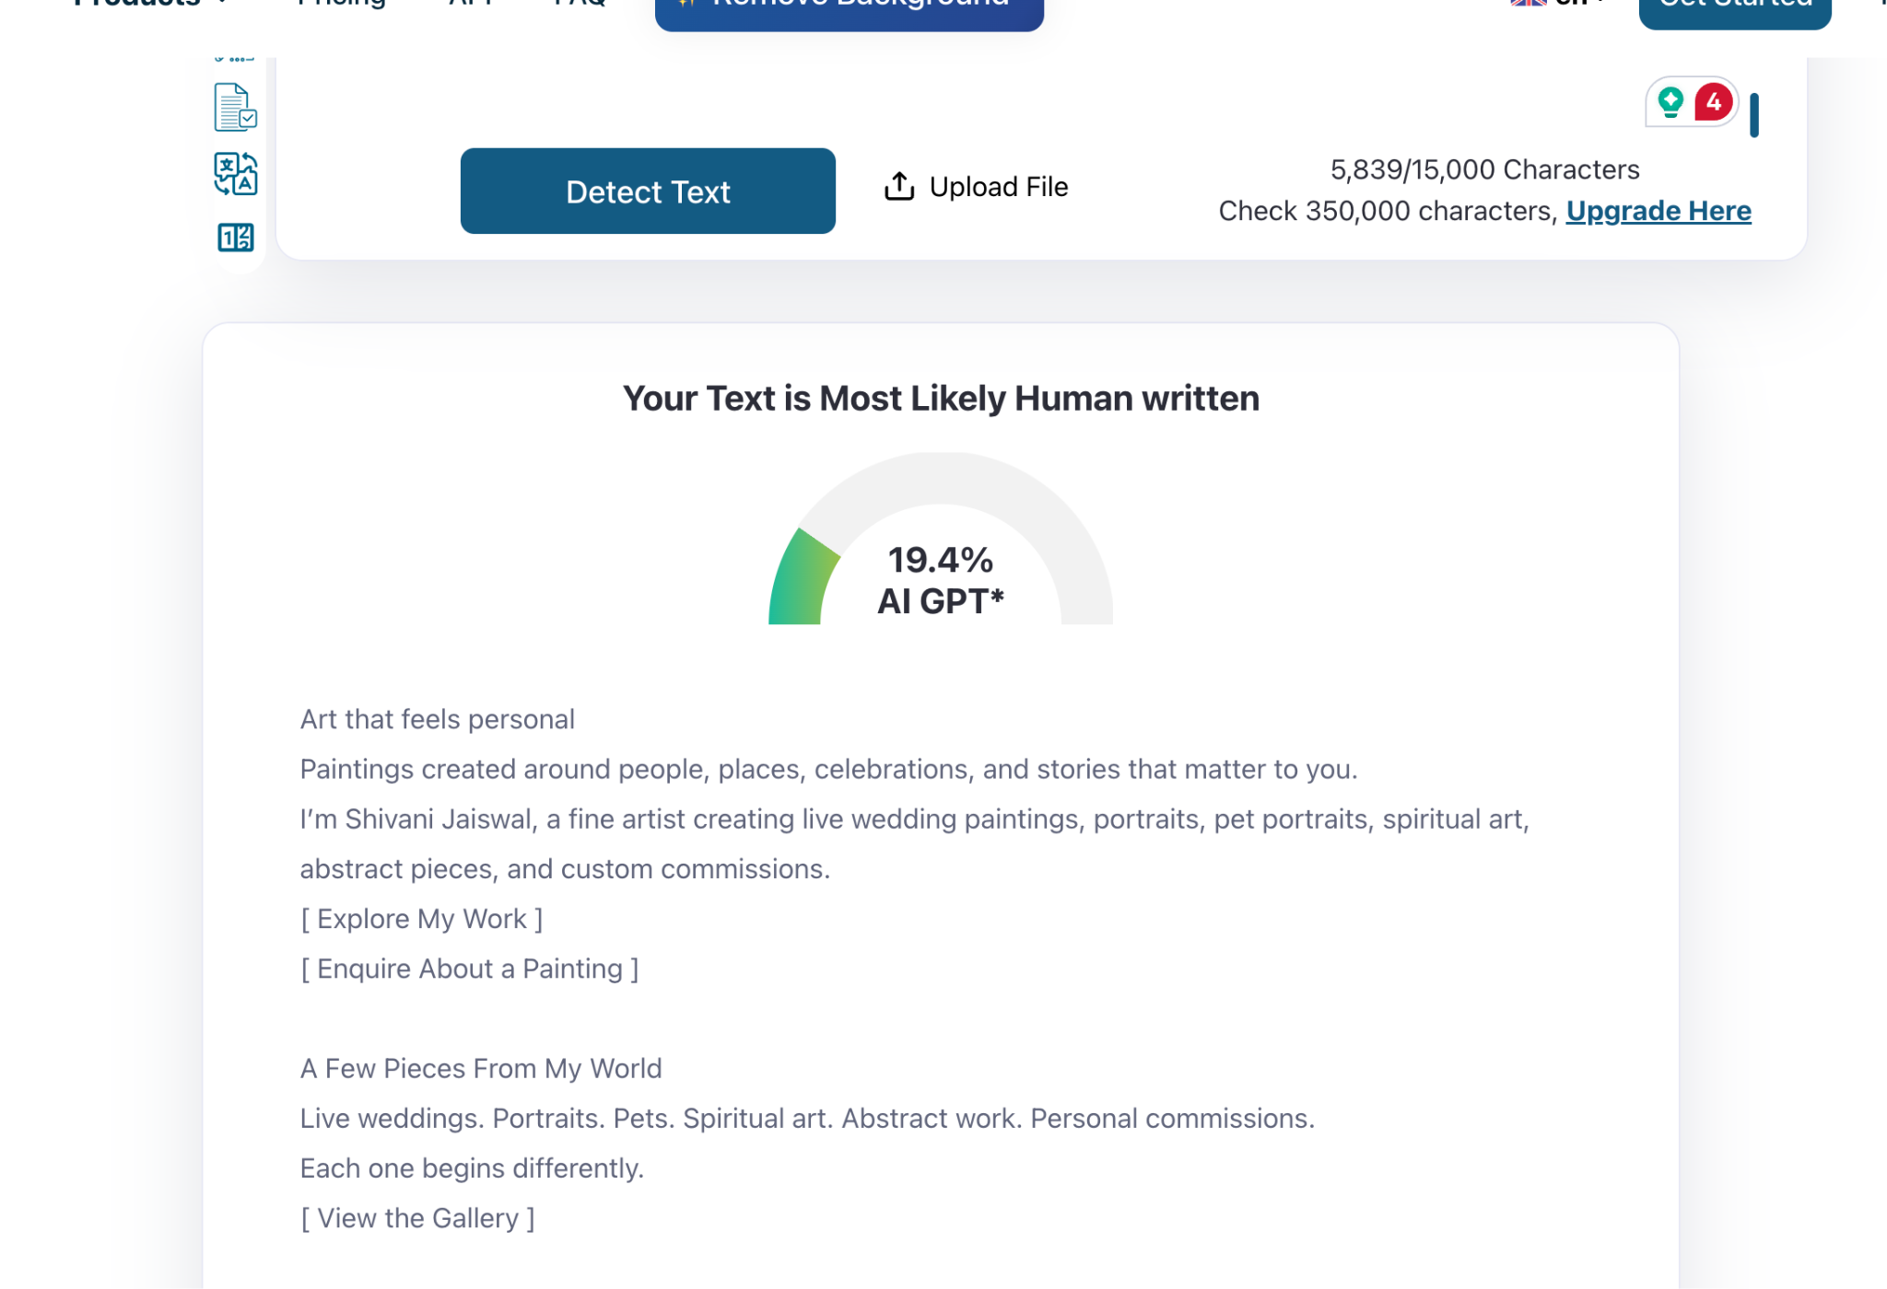
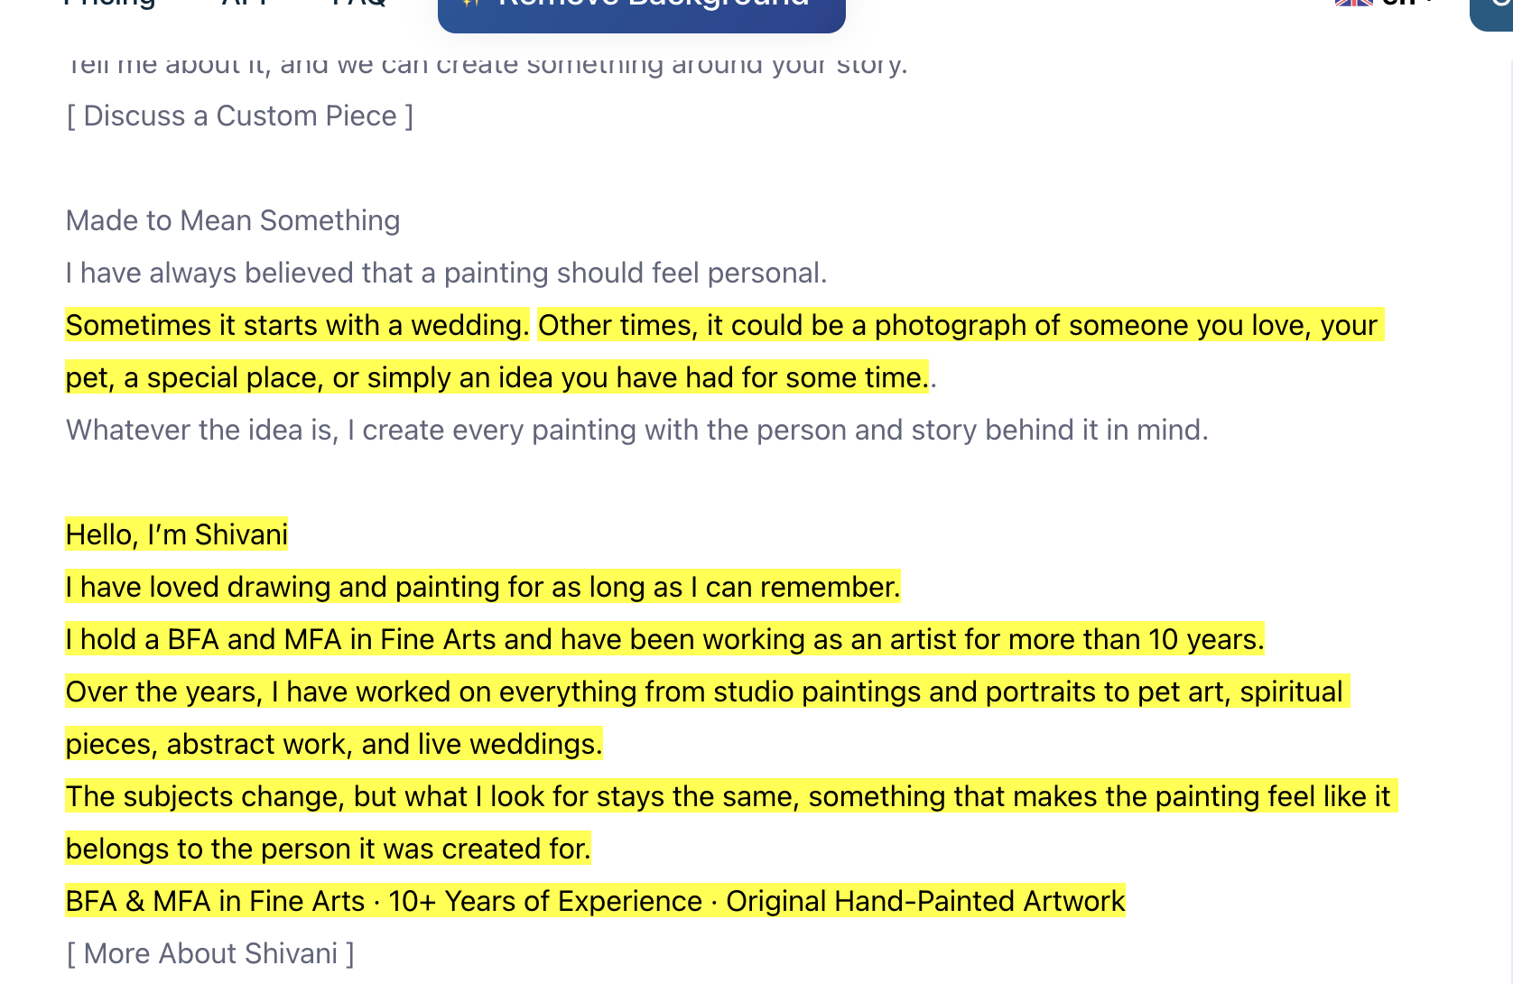

This part is also self-written, but it is still being detected as AI.

